**AIM:** Write a program to implement fuzzy set operations

**SOURCE CODE:**

**Union**

A = dict()

B = dict()

Y = dict()

A = {"a": 0.2, "b": 0.3, "c": 0.6, "d": 0.6}

B = {"a": 0.9, "b": 0.9, "c": 0.4, "d": 0.5}

print('The First Fuzzy Set is :', A)

print('The Second Fuzzy Set is :', B)

for A_key, B_key in zip(A, B):

    A_value = A[A_key]

    B_value = B[B_key]

    if A_value > B_value:

        Y[A_key] = A_value

    else:

        Y[B_key] = B_value

print('Fuzzy Set Union is :', Y)

**OUTPUT:**

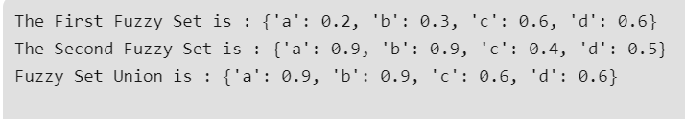

**Intersection**

A = dict()

B = dict()

Y = dict()

A = {"a": 0.2, "b": 0.3, "c": 0.6, "d": 0.6}

B = {"a": 0.9, "b": 0.9, "c": 0.4, "d": 0.5}

print('The First Fuzzy Set is :', A)

print('The Second Fuzzy Set is :', B)

for A_key, B_key in zip(A, B):

    A_value = A[A_key]

    B_value = B[B_key]

    if A_value < B_value:

        Y[A_key] = A_value

    else:

        Y[B_key] = B_value

print('Fuzzy Set Intersection is :', Y)

**OUTPUT:**

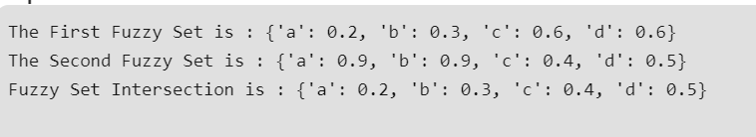

**Compliment**

A = dict()

Y = dict()

A = {"a": 0.2, "b": 0.3, "c": 0.6, "d": 0.6}

print('The Fuzzy Set is :', A)

for A_key in A:

   Y[A_key]= 1-A[A_key]

print('Fuzzy Set Complement is :', Y)

**OUTPUT:**

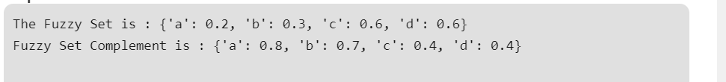

**Difference**

A = dict()

B = dict()

Y = dict()

A = {"a": 0.2, "b": 0.3, "c": 0.6, "d": 0.6}

B = {"a": 0.9, "b": 0.9, "c": 0.4, "d": 0.5}

print('The First Fuzzy Set is :', A)

print('The Second Fuzzy Set is :', B)

for A_key, B_key in zip(A, B):

    A_value = A[A_key]

    B_value = B[B_key]

    B_value = 1 - B_value

    if A_value < B_value:

        Y[A_key] = A_value

    else:

        Y[B_key] = B_value

print('Fuzzy Set Difference is :', Y)

**OUTPUT:**

